
press release
(English translation)

MIR 2025 - DAILY NEWS MONDAY MARCH 24

FROM VASCO TO LAURA PAUSINI: MIR SHARES THE STORIES OF MAJOR MUSICAL EVENTS
A privileged perspective into the world of concerts at MIR – Multimedia Integration Expo, as it transforms into a stage for backstage artists. The IEG Expo Centre in Rimini is the platform for a wealth of events showcasing the creative process behind the production of shows. One such event is dedicated to Vasco Rossi's concert at San Siro in 2024, featuring director and show director Pepsy Romanoff, Fabio 'Fubah' Pini, the art director, and Lorenzo Venturini, the notch designer. Together, they offer a behind-the-scenes look at one of the most complex shows ever produced. The concert boasted a 30-person strong direction and creative team and was developed with a 4K multi-shot filming concept. Each shot featured distinct effects, managed in real-time with AI assistance, and projected onto a massive 1,280 square metre (58x22 metre) screen. Pepsy Romanoff underlined, “A unique show, where new concert methodologies were employed, enabling us to experiment with techniques that can now be utilized in other events.”
Earlier this morning, Lorenzo de Pascalis, founder of Ombra Design, led a meeting to outline the creative process behind a major event. This included the conceptualisation, which involved extensive rendering work, the selection of lights, lasers, stage, and visuals, and the coordination of departments through software. Lorenzo De Pascalis remarked: “We use artificial intelligence to create initial elements, but in practice, we still gravitate toward human input”.
The journey through the world of major shows continued this afternoon with a masterclass on the audio production of Laura Pausini's tour, led by sound engineer Marco Monforte. This session delved into the intricacies of a world tour, encompassing design, implementation, and logistics. Finally, in the realm of Show Design, Pepsy Romanoff uncovered the creative process he employs, blending music and images to craft his iconic works.

UNLOCKING THE SECRETS TO TRANSFORMING YOUR DIGITAL PASSION INTO A CAREER
This morning, during the “Content Creator Music Lab” meeting with Federico Doria and Jacopo Griffante at MIR – Multimedia Integration Expo, strategies were explored for transforming digital content creation into a full-fledged career. Doria, with his DJ and YouTuber background, and Griffante, a renowned content creator in the clubbing scene, shared practical tips on how to make your mark in the digital landscape. Knowing your target audience is crucial: without this understanding, it's challenging to create content that truly resonates. The discussion then shifted to the importance of analysing the unique qualities of competitors. The core of the discussion hinged on the 3 “I’s” rule, where each piece of content should involve, inform, and inspire. Through anecdotes and advice, the message was crystal clear: with perseverance, strategy, and a well-defined identity, social media can evolve from a mere showcase into a genuine career. And the discussion didn’t end stop there. In the afternoon, the Rimini venue hosted the event 'What's TV?' From spectators to scrollers: entertainment today, featuring the small screen at MIR. Not just traditional TVs, but all digital, social, and mobile devices. The feature explored how these changes impact not only where we consume content, but also how we experience it and what we expect from new forms of entertainment.

THE EVOLUTION OF CORPORATE SPACES IN THE AGE OF WORK 4.0
Corporate environments are rapidly evolving, transforming into dynamic spaces that seamlessly blend technology and creativity to deliver innovative and engaging experiences. Showrooms, training rooms, and common areas serve as innovative showcases, fostering dialogue between stakeholders with diverse skills and backgrounds. This evolution, as explained at MIR in Rimini during this afternoon's event “Work 4.0: the future of offices between videoconferencing, smart buildings, and artificial intelligence”, is part of the transformation of the world of work towards the fourth-generation paradigm, where physical presence is integrated with remote work. Hybrid, flexible, and intelligent spaces, designed to ensure operational continuity and employee well-being. Smart buildings and advanced technologies optimise energy consumption, comfort, and safety, while artificial intelligence solutions and video conferencing systems facilitate increasingly immediate and inclusive collaboration. Corporate spaces transcend their traditional roles, evolving into dynamic ecosystems that foster broad participation and inclusion.

ABOUT MIR 2025
Date: 23/25 March 2025; event type: international expo; organizer: Italian Exhibition Group S.p.A.; recurrence: annual; edition: 9th; open to: general public and professional operators; info: www.mirtechexpo.com

PRESS CONTACT ITALIAN EXHIBITION GROUP
head of corporate communication & media relation: Elisabetta Vitali
press office manager: Marco Forcellini, Pier Francesco Bellini | press office coordinator: Luca Paganin | international press office coordinator: Silvia Giorgi | press office specialist: Mirko Malgieri; Nicoletta Evangelisti | media@iegexpo.it

MEDIA AGENCY MIR
Naper Multimedia| Zoe Perna | T. +39 02 97699600 | zoe.perna@napermultimedia.it | staff@napermultimedia.it

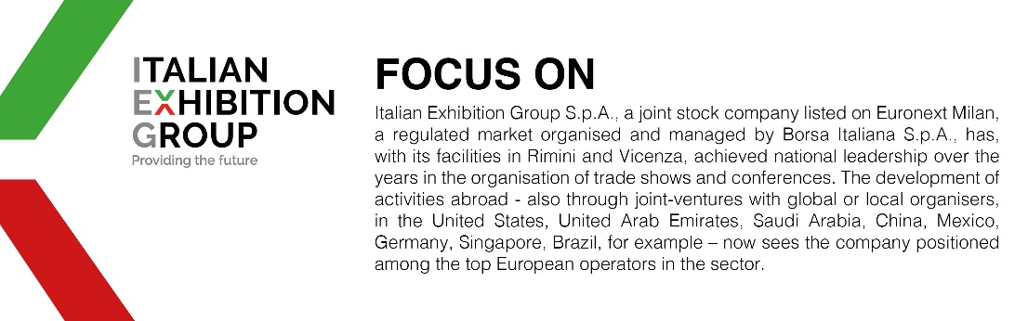

This press release contains forecast elements and estimates that reflect the management´s current opinions (´forward-looking statements´), particularly regarding future management performance, realization of investments, cash flow trends and the evolution of the financial structure. For their very nature, forward-looking statements have a component of risk and uncertainty, as they depend on the occurrence of future events. The effective results may differ (even significantly) from those announced, due to numerous factors, including, only by way of example: food service market and tourist flow trends in Italy, gold and jewellery market trends, green economy market trends; the evolution of raw material prices; general macroeconomic conditions; geopolitical factors and evolutions in the legislative framework. Moreover, the information contained in this release, does not claim to be complete, and has not been verified by independent third parties. Forecasts, estimates and objectives contained herein are based on the information available to the Company as at the date of this release.

